

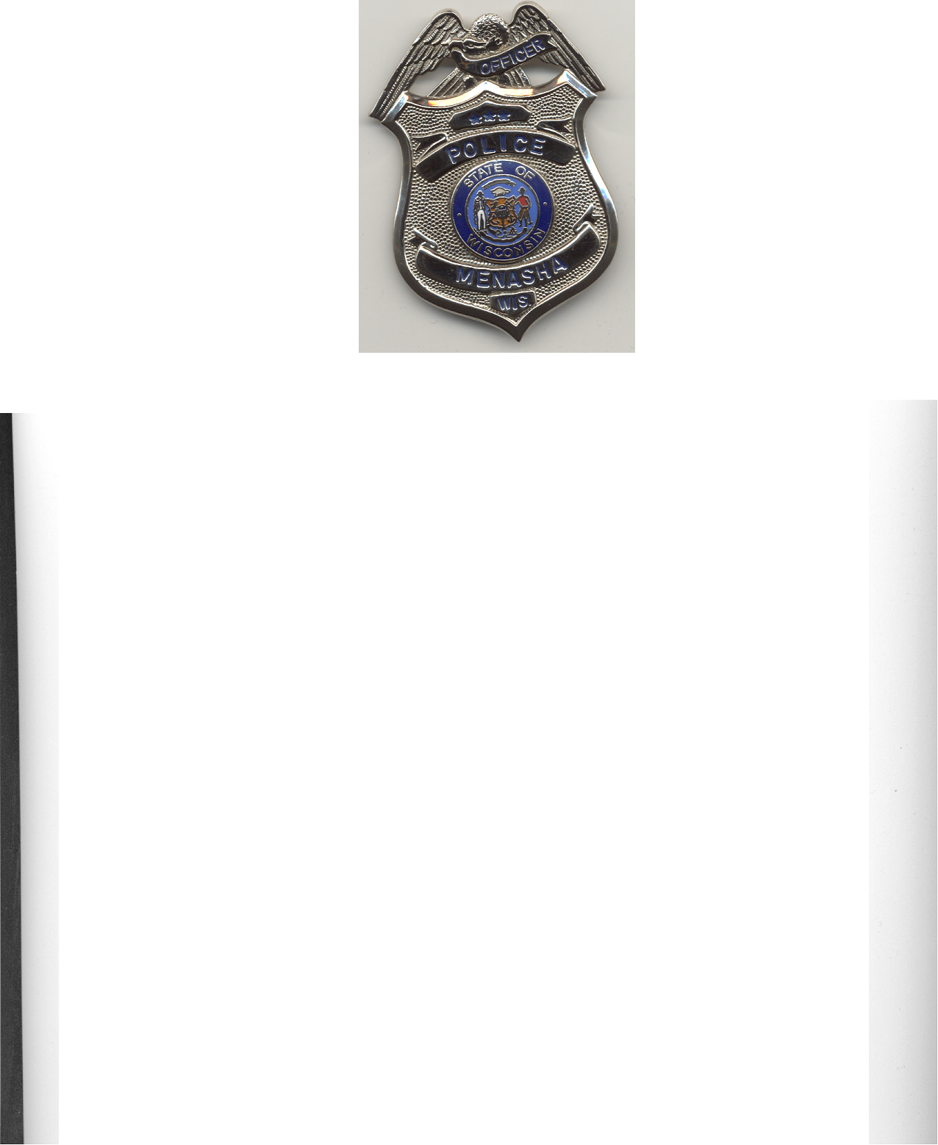
Menasha Police Department

Crime Prevention
Patrol Division

Menasha Police Neighborhood Watch E-mail group
Application for Participation

Please type or print

Name:___________________________________________________________
Last First Middle

Date of Birth: _____Email address________________________________

Street Address:

Home Telephone: _______

Please explain briefly why you wish to be enrolled in the neighborhood watch e-mail group:
________________
Please list any associations, clubs or organizations you belong to:
_____________________
Certifications

“I understand that the Menasha Police Department will be verifying the information contained in this application. I give the Menasha Police Department authorization to conduct a background check prior to my being accepted in the e-mail group. I understand that my acceptance into this e-mail group is directly based on the results of that background check. By submitting this application I agree to call the Menasha Police when I see suspicious activity occurring. I further understand that if I act inappropriately with any of the information received it will cause my immediate termination from this e-mail group.”

Applicants Signature: _ Date:

Return completed application to; Officer Aaron Zemlock, Menasha Police Department, 430 First Street, Menasha, WI 54952 /FAX (920)-967-5145 Attn: Aaron

Menasha Police Department, Crime Prevention 430 First Street, Menasha, WI 54952
Phone (920)967-3550 Fax (920)967-5145 email: azemlock@ci.menasha.wi.us
Website http://www.menashapolice.org

